**Angular JS**

Angular js is a single page application

All present applications like facebook, etc., are using this

Initialise bower bower init

Create index.js

Installing angular js

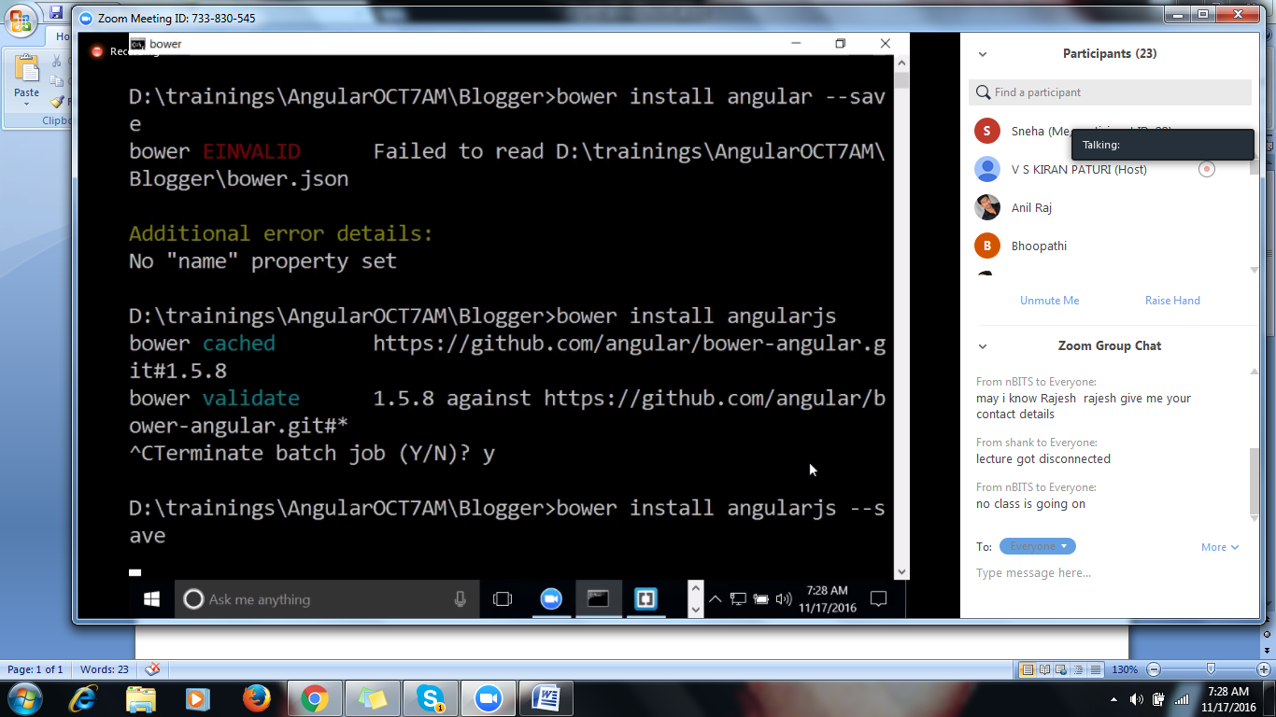

To work with the angular Js , we need to include angular Library

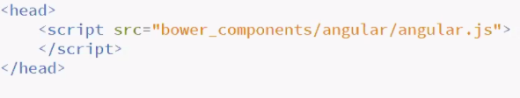

To start angular application we will use concept called auto bootstrapping( whenever u want to angular we need to hook directive)

**ng-app**

* Ng-app is called a directive; the purpose of ng-app is to integrate the features of angular to the html page.
* Ng-app will make the html page with the angular features but the location of declaring the ng-app is important
* The moment we add ng-app will scan the entire html page
* Will make an entry in the memory saying Ng-model and ng-bind are being used in this html page for example:

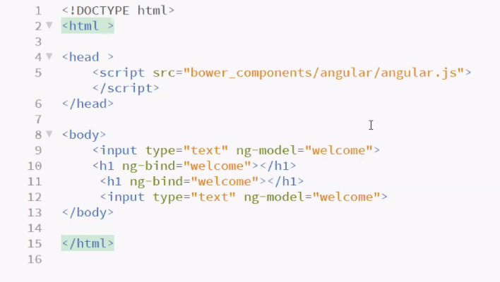

If any key is pressedby user in ng-model,it thinks that it shoul update in ng-bind.

Data Binding:

There are 2 kinds of databinding available with the angular

2 – way binding

1. Way binding

2-way binding will always update the data

1-way binding will update data only once,can also called as one time binding

We will go for 1-way binding in case of

1-way binding is rcommended when u are expecting the data that is not going to change(read only data purpose)

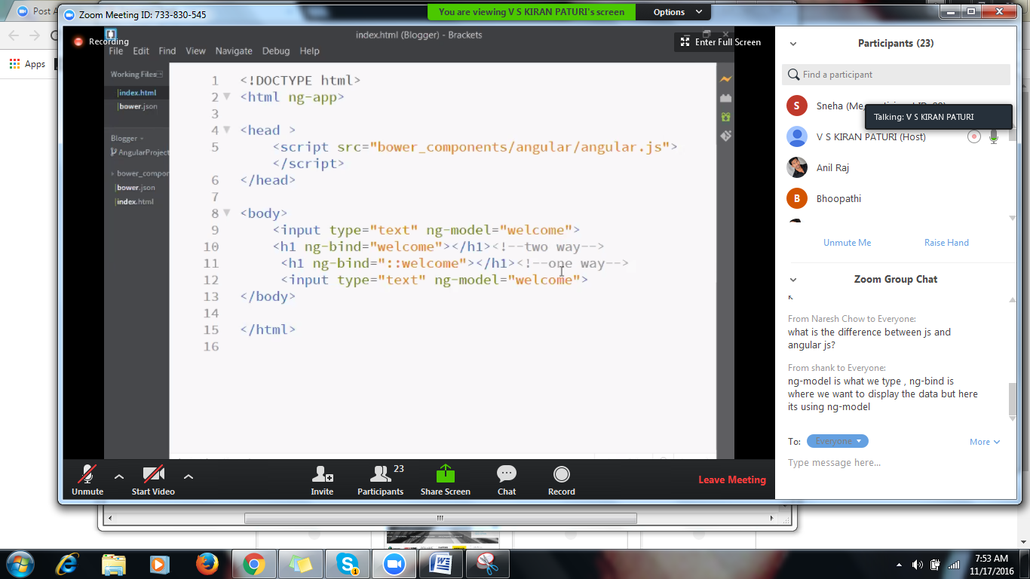

Dat-information

Binding-Presentation

The moment we are presenting the data, will update in the header

Ng-model is a directive that can take the data for all input data controls we will use ng-model(for entering the data)

Ng-bind(displaying the data)